Lesson 14: Scientific Notation
GETTING YOURSELF READY
Materials:  Answers to last night’s independent practice  Misconception to New Understanding Sheet  Student Handouts  Mini whiteboards  Closure cards |  |  | Your Preparation:  Put last night’s Independent Practice Answer Key and the Misconception to New Understanding Worksheet on a table for students to pick up on their way in to class. |  | Agenda with times:  Do Now and Purpose: 7 minutes  Key Vocabulary: 3 minutes  Building the Skill: 20 minutes  Structured Practice: 10 minutes  Guided Practice: 10 minutes  Closure: 3 minutes
GETTING YOUR STUDENTS READY
*Do Now:
Check handout, complete Misconception sheet for trickiest problem that one got wrong
Objective: Today you will be able to understand the connection between patterns of ten and scientific notation. |  |  |  | Proving Behavior: By writing data in scientific notation and standard form and using data presented in scientific notation to calculate mean with 80% accuracy.
Purpose: We are doing this because we want to see how finding patterns can help us learn math and understand how scientific notation can help us in recording very large numbers.
Key Vocabulary: (from Glencoe.com)
Create vocabulary cards with these definitions and a picture to represent them and hang on the word wall. Use the cards to ask the students the given questions about the vocabulary and have them respond chorally or on their mini-whiteboards.

Scientific Notation – a method of writing very large or very small numbers by writing them as a product of ten
Standard Notation – writing out a number without any operation symbol
BUILDING THE SKILL
Scientific Notation: | Say: Think of texting. Not everyone writes in complete sentences, right? There are abbreviations to words that are understood nearly universal. So is the case for scientific notation, used to “abbreviate” large numbers  Scientific Notation is a way of writing very large or very small numbers. For example, if we want to talk about the distance from Earth to the Sun, we could use scientific notation instead of saying the very large number. Today, we are going to look at very large numbers and connect scientific notation to patterns we notice with products of ten.  See: Show the box at the top of the guided notes, pointing out the scientific notation and the actual number in standard form.  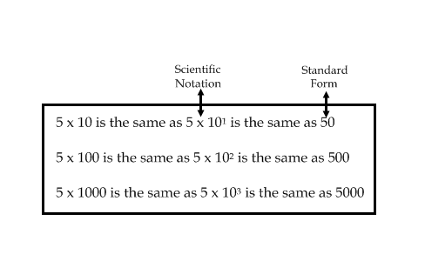  Do: Have the students write the next line that they might see in this box. Have them read it aloud chorally on the count of three: “5 x 10,000 is the same as 5 x 10⁴ is the same as 50,000.”
Say/See: When we look at this chart, we can see some patterns with the products of ten. Our first question asks us to look for a pattern between the number of zeros recorded after the “1” and the power that ten is raised to. (Point to this question and point to the arrow that connects these two things.) When I look at the first example, I see that there is one zero after the 1 and that the exponent is one. As a mathematician looking for a pattern, I am wonder if the number of zeros after the 1 is the same as the exponent?
Do: Have students check the other two examples to see if this pattern works. Have students put their thumbs up or down to confirm the pattern. Then, have the students write in complete sentences the pattern under number one. Then, have them pair share a response to number two and cold call on a student to respond to number two after they pair share. Record the answer for all to see.
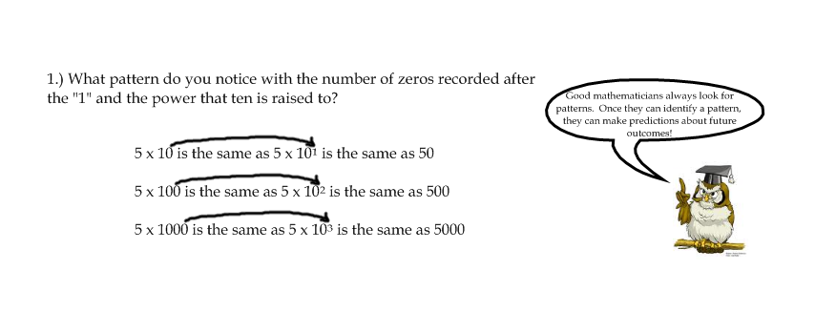
Say/See: Now, when we look at the chart, we are going to try to connect the power of ten to the number of place values the decimal moves. (Point to the question and the arrows connecting these two things.)
Do: Have the students work with their partner and make a connection. Then, have them check this pattern/connection with the other two examples. Then, have them write the pattern in complete sentences. Cold call on partner groups to read their complete sentences. Make sure they are using mathematical vocabulary such as exponent and place values. Lastly, have them work with their partner and answer number 4. Then, record the answer for all to see.
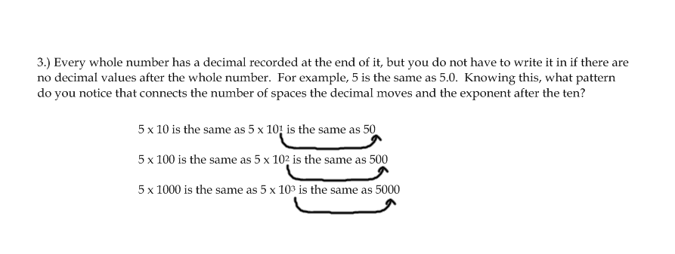
Say: We can multiply and divide numbers that are in scientific notation.
See: Look at number five:

5.) What if I wanted to multiply the following and record it in scientific notation: (2 x 10²) x (4 x 10⁵). Is there an easy way to compute the solution? Explain.

Say/See: If I wanted to multiply using the numbers in standard form, I could change 2 x 10² to 200 and 4 x 10⁵ to 400000 and then multiply those to get 80000000. (Write these numbers below each scientific notation as you compute so students can see your work.) Since I’m a mathematician, I am looking for a way to connect to the patterns I have found. I know that 80000000 can be written in scientific notation as 8 x 10⁷. I wonder if there is a way for me to get that answer without first changing each scientific notation to standard form? Also, must change number to scientific notation if necessary.
Do: Have the students pair share a hypothesis as to how they might get 8 x 10⁷ without first converting to standard form. Share the answer aloud: “You could multiply 2 times 4 and get the 8 and then write times ten and add the two powers to find the new power.” Have students write the explanation in complete sentences.

Say/See: Very large numbers (e.g. size of sun, number of people on the Earth)
Do: Express them in scientific notation with a partner. Maybe for a few of them, I’ll omit the numbers and have the students ballpark/estimate them using scientific notation
PRACTICING THE SKILL
*Structured Practice
Time: 10 minutes  Materials:  Group Size: 4 |  | - Have students work with a partner and complete 1 and 2 on their whiteboards for a whiteboard drill. Once you see their answer is correct, have them write it on their worksheet.  - Think aloud number 3, showing the students how to apply finding the mean to numbers in scientific notation. Have them change the numbers into standard form and add the decimals then divide by two. Remind them to line up the decimals when they add them. Show your division. Then, have the students pair share and record the work on their sheet together.  - Have students work with a partner on number four and think aloud the response to why the answer can be written in scientific notation. Then, have the students write the response in their words on their worksheet.
*Guided Practice (the proving behavior of the objective monitored by teacher)
Assignment: Guided Practice Worksheet. Give students the answer key when as they finish, so they can correct and either explain to you their mistakes right away or make a note to meet with you if they have some misconceptions. They must be able to explain their mistakes and hit the criteria for mastery before being allowed to complete their independent practice. |  |  |  |  |  | Criteria for Mastery: 4/5
Explain Homework: Independent Practice Worksheet. Have students show their work and complete the problems.
*Closure: Write on an index card: estimate the number of jelly beans that can fit in the classroom using scientific notation. Be sure to justify!

